WORLD SCIENTIFIC and ENGINEERING
ACADEMY and SOCIETY
http://www.wseas.org

Professor Charles A. Long,  WSEAS President, Professor Emeritus, University of Wisconsin, Stevens Point, Wisconsin, USA | WSEAS, A. I. Theologou 17-23,  15773, Zographou, Athens, GREECE
WSEAS, Philippe Dondon, ENSEIRB rue A Schweitzer 33400, Talence, FRANCE | WSEAS, Yiming Li, Microelectronics & Inform. Research Center, National Chiao Tung Univ., Hsinchu 300, TAIWAN
WSEAS, Valeri M. Mladenov, Technical University of Sofia  Sofia-1000, BULGARIA | WSEAS, Petr Ekel, Av. Dom Jose Gaspar, 500, 30535-610 - Belo Horizonte – MG, BRAZIL
WSEAS, Alexander Zemliak, Physics & Mathem. Dept., Puebla Auton. University, MEXICO | WSEAS, Minh Hung Le, School of Electrical and Computer Engineering, International Business College, AUSTRALIA
Date (fill in the date)
Dear Dr. (please complete your name),

We are pleased to inform you that your paper submitted to please, fill in the title of the conference is accepted for presentation in a regular session. The conference will be held at please, fill in the place and the dates of the conference. All papers were rigorously peer reviewed. Please note that regular session papers will be published in the conference proceedings. They should be registered and prepared in accordance guidelines available at: http://www.worldses.org/conferences/wseas-kit.htm
Paper ID number: please, fill in the ID number of your paper
Title: please, fill in the title of your paper
Authors: please, fill the author names
Your presence at the event would be a really great honour for WSEAS. The WSEAS conferences offer to researchers and university faculty members from all around the world the opportunity to rendezvous with colleagues, share new research advances and ideas, and set up new collaborations and research projects. Many well-known and distinguished scholars will attend the meeting. We cordially invite you to join this unique event. You will have the opportunity to attend it and to receive the proceedings with your paper. All the WSEAS Conference Proceedings are available on-line for the academic community. The authors of the best papers of the conference will be invited to submit an extended and enhanced version of their paper for possible journal publication in reputable international journals after additional peer review. Updated information about the conference can be found at, please, fill in the URL of the conference
This letter is being sent to you for possible financial support from your department, as well as for VISA grant.
Best Regards

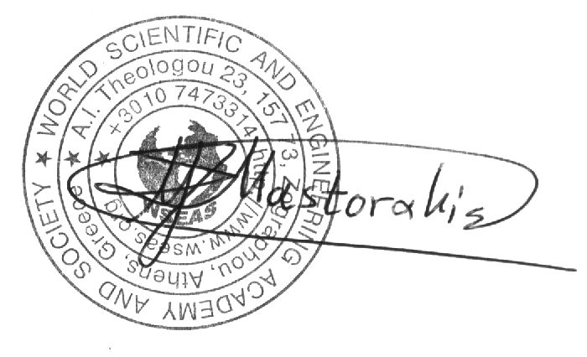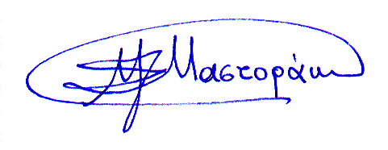
Prof. Dr. Nikos Mastorakis, WSEAS President, SM of IEEE
Head of the Department of Computer Science
Military Inst. of University Education / Hellenic Naval Academy
Terma Hatzikyriakou 18539, Piraeus, GREECE. www.wseas.org/mastorakis

