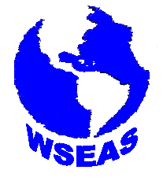 | WSEAS TRANSACTIONS  on MATHEMATICS  Issue 10, Volume 5, October 2006  ISSN 1109-2769 http://www.wseas.org
Nonsimilar Solutions for Natural Convection Heat and Mass Transfer near a Permeable Horizontal Cylinder of Elliptic Cross Section in Porous Media | 1095
Ching-Yang Cheng
Boundary Conditions for Low Mach Number Reacting Flows | 1102
Robert Prosser
Involutive Brouwerian D-algebras | 1108
Mircea Sularia
Development of Irregular-Grid Finite Difference Method (IFDM) for Governing Equations in Strong Form | 1117
George Xu, G. R. Liu
Region of Interest Detection using Jensen-Shannon Divergence for Fluorescence Image of Skin lesion | 1123
C. Atae-Allah, A. Atae-Allah, I. Rojas, F. Rojas, O. Valenzuela, J. F. Gomez Lopera
Evaluation of NPS Pollution in Drinking Water Protection Area of Kaoping River Watershed | 1131
T. C. Yang, C. M. Kao, T. Y. Yeh, C. E. Lin, Y. C. Lai
Fuzzy versus Statistical Regression in False-Twist Texturing | 1138
S. M. Taheri, H. Tavanai, M. Nasiri
Phytoremediation and Microbial Transformation of Contaminants within Treatment Train Natural Purification Systems | 1146
T. Y. Yeh, C. Yuan, C. C. Chuang, C. H. Ju

